

American International University-Bangladesh (AIUB)

**Department of Computer Science Faculty of Science & Technology (FST)**

**Emergency Security Services**

### A Software Requirement Engineering Project Submitted

### By

|  |  |  |  |  |
| --- | --- | --- | --- | --- |
| **Semester: Spring_22_23** | | **Section: G** | **Group Number:09** | |
| SN | Student Name | Student ID | Contribution (CO1+CO2) | Individual Marks |
| 03 | MIRZA NAFIS MAHMUD | 18-39037-3 |  |  |
| 39 | TUYAN JAMAMIM | 20-43978-2 |  |  |
| 14 | MD. TANVIR HOSSEN | 20-42488-1 |  |  |
| 37 | SHAWON SUTRADHAR | 20-43487-1 |  |  |
|  |  |  |  |  |

The project will be Evaluated for the following Course Outcomes

|  |  |  |
| --- | --- | --- |
| Evaluation Criteria | Total Marks (50) | |
|  | |
| Introduction, Format, Submission, Defense | [10 Marks] |  |
| System Overall Description & Functional Requirements | [10 Marks] |  |
| System Quality Attributes and Project Requirements | [10 Marks] |  |
| UML and E-R Diagram with Data Dictionary | [10 Marks] |  |
| UI/UX Prototyping | [10 Marks] |  |

Table of Contents

1. Introduction 3
   1. Purpose 3
   2. Document Conventions 3
   3. Intended Audience and Reading Suggestions 3
   4. References 4
2. Overall Description 4
   1. Product Perspective (Business Requirements) 4
   2. Product Functions 5
   3. User Classes and Characteristics 5
   4. Operating Environment 6
   5. Design and Implementation Constraints 7
   6. User Documentation 7
3. System Requirements 8
   1. System Features 8
   2. Non-Functional/Quality Requirements 10
   3. Project Requirements 11
4. Interface Requirements 12
   1. UML 12
   2. UI/UX Design Specification 15

# Introduction

## Purpose

This software requirements specification (SRS) document describes the requirements for the Emergency Security Service mobile application. The app will allow users to quickly and easily access emergency services, such as police, fire, and ambulance. The app will be available for both Android and iOS devices.

The Emergency Security Service mobile application will allow users to do the following:

* Report an emergency
* Get directions to the nearest emergency services
* View a map of emergency services in the area
* Contact emergency services by phone

The app will be available in multiple languages and will be accessible to users with disabilities.

The Emergency Security Service mobile application will provide the following benefits to users:

* Faster and easier access to emergency services
* Increased safety and security
* Reduced risk of injury or death

The Emergency Security Service mobile application is aligned with the following corporate goals and business strategies:

* Improve customer satisfaction
* Increase market share
* Reduce costs

The Emergency Security Service mobile application is aligned with the corporate goals of the company to provide a safe and secure environment for its employees and customers. The application is also aligned with the business strategy of the company to improve customer service and satisfaction.

## Document Conventions

This document uses the following conventions:

* All requirements are numbered for easy reference.
* Requirements are written in a clear and concise manner.
* Requirements are prioritized to indicate their importance.
* Requirements are traceable to the business needs that they support.

Here are the document conventions that were followed when writing this SRS:

* Font: Times New Roman
* Size: 12
* Space: 1.0
* Alignment: Justify

In addition to these general conventions, the following typographical conventions were used to indicate the significance of certain text:

* Bold: Used for headings and important text
* Italics: Used for emphasis
* Underline: Used for links

Priorities for higher-level requirements are assumed to be inherited by detailed requirements. However, every requirement statement is also to have its own priority. This is to ensure that all requirements are considered equally important, regardless of their level of detail.

Here is an example of a requirement statement with a priority:

**Requirement**: The app must be available in multiple languages.

**Priority**: High

This requirement has a high priority because it is important for the app to be accessible to users from all over the world.

## Intended Audience and Reading Suggestions

This document is intended for the following audiences:

* Developers
* Project managers
* Marketing staff
* Users
* Testers
* Documentation writers

The document is organized as follows:

* Introduction
* Overall Description
* System Requirements
* Interface Requirements

The document can be read in any order, but it is recommended that readers start with the introduction and then proceed to the sections that are most relevant to their role.

* **Developers:** Those responsible for designing and implementing the software system.
* **Project Managers:** Those responsible for overseeing the project and ensuring that it is completed on time, within budget, and to the required quality standards.
* **Marketing Staff:** Those responsible for promoting and selling the software system to potential customers.
* **Users:** Those who will be using the software system to access emergency security services.
* **Testers:** Those responsible for verifying that the software system meets all of the specified requirements and functions correctly.
* **Documentation Writers:** Those responsible for creating user manuals, help files, and other types of documentation related to the software system.

## References

This SRS refers to the following documents and web addresses:

* B. A. Kitchenham et al., "Preliminary guidelines for empirical research in software engineering," in IEEE Transactions on Software Engineering, vol. 28, no. 8, pp. 721-734, Aug. 2002, doi: 10.1109/TSE.2002.1027796.
* Richard H. Thayer, Merlin Dorfman (Editors). Software Requirements Engineering. Wiley- IEEE Press; 2nd edition (©2000). 1st Edition: 1997.
* Eko Handoyo, R Rizal Isnantoa,, “SRS Document Proposal Analysis on the Design of Management Information Systems According to IEEE” STD 830-1998, Procedia - Social and Behavioral Sciences, Volume 67, 2012, Pages 123-134, ISSN 1877-0428, <https://doi.org/10.1016/j.sbspro.2012.11.313>.
* Rokkhi- <https://www.rokkhi.com/>

# Overall Description

* 1. **Product Perspective**

A brand-new, standalone product called the Emergency Security Services (ESS) system is being created to offer complete security services to enterprises and organizations. The system is made to be extremely adaptable and flexible so that it may be tailored to match the specific security requirements of each and every customer.

A mobile-based application, the ESS system will be accessible from any device with an internet connection. Modern construction techniques will be used, and cutting-edge security measures will be included to guarantee that customer data is always kept safe and secure.

The ESS system is a standalone product, but it will also need to interface with external systems, such as third-party security providers, emergency response services, and customer databases. A simple diagram that shows the major components of the overall system and their interconnections is provided below:

The ESS system will play a significant role in our entire business strategy since it will enable us to provide our clients with a full range of security services. We believe that by offering a highly adjustable and configurable solution, the ESS system will help us stand out from our rivals and position ourselves as the market's top supplier of security services.

## Product Functions

The ESS system must be able to perform the following major functions:

* **User management:** The system must allow administrators to create and manage user accounts, with different access levels and permissions.
* **Incident reporting and management:** The system must allow users to report incidents and for administrators to manage and track incidents from start to resolution.
* **Asset management:** The system must allow users to manage and track their assets, such as equipment, vehicles, and personnel.
* **Dispatch management:** The system must allow dispatchers to manage and track security personnel in the field, assign tasks, and monitor progress.
* **Communication management:** The system must allow for real-time communication between security personnel, dispatchers, and administrators.
* **Reporting and analytics:** The system must allow for the generation of reports and analytics to track performance, identify trends, and make data-driven decisions.

A top-level data flow diagram (DFD) or object class diagram can be provided to give a visual representation of the major groups of related requirements and how they relate.

## User Classes and Characteristics

The Emergency Security Services (ESS) system is designed to serve the following user classes:

* **Security personnel:** These users will use the system regularly to report events, manage assets, accept assignments, and get in touch with dispatchers and administrators. They are the system's primary users. They may access the system via various devices and will have differing degrees of technological competence.
* **Dispatchers:** The system will be used by these users to assign assignments, track progress, and manage security personnel in the field. They could need to make quick judgments based on real-time data, which will need a high level of technical skill.
* **Administrators:** These people will administer user accounts, establish permissions and access levels, produce reports and analytics, and keep track of system performance using the system. They will have access to all system features and will need a high level of technical skill.

The pertinent characteristics of each user class are as follows:

* **Security personnel:** Different devices and levels of technical knowledge, as well as familiarity with security protocols, may be used to access the system.
* **Dispatchers:** High level of technical proficiency, the capacity to decide quickly based on current information, and knowledge with dispatch protocols and procedures.
* **Administrators:** High level of technical knowledge, proficiency in setting up permissions and access levels for users while managing user accounts, and familiarity with system management and monitoring protocols.

Security professionals are the most crucial user group for this product because they will be the system's key users and utilize it frequently to carry out their jobs. All user classes must be satisfied, though, as they each play a crucial part in the system's smooth running.

## Operating Environment

The environments in which the Emergency Security Services (ESS) software will function include a variety of hardware and software elements. The hardware platform will be made up of servers, laptops, desktop computers, and mobile devices that adhere to the software vendor's minimum specifications. The ESS software needs mobile operating systems like Android and iOS.

The ESS program will communicate with other software elements and applications, such as a database management system and a geographic information system (GIS), in addition to the operating system and web browser. To show maps and visualize data pertaining to emergency situations, the ESS program will need to be used with a GIS. The GIS should work with the program and be able to handle the data format that the ESS program uses.

To connect to the central server and other emergency services systems, the ESS software will also need an internet connection. The internet connection needs to be reliable and have enough capacity to manage the amount of data that the software generates. It is also recommended that the software be used in a secure environment with appropriate antivirus and firewall protection to ensure the security of sensitive data.

## Design and Implementation Constraints

The design and implementation of the Emergency Security Services (ESS) software will be subject to a number of constraints that may limit the options available to developers. Some of these constraints are:

* **Technology:** The customer's organization must accept the use of particular programming languages, software development frameworks, and database management systems when creating the ESS software. To ensure interoperability with current systems or to adhere to organizational policies, certain technologies could be necessary.
* **Security:** Security considerations are of the utmost importance because the ESS program will handle sensitive data relating to emergency occurrences. Industry-accepted security procedures and standards, such as data encryption, access controls, and secure communication protocols, must be followed by the software.
* **Performance:** Real-time processing of a sizable volume of data and transactions must be possible with the ESS software. Performance and scalability are crucial factors as a result. The software must be made to use resources efficiently and respond as quickly as possible.
* **User interface:** Emergency responders with various degrees of technical competence must be able to use the ESS software's intuitive and user-friendly interface. Additionally, the user interface needs to be made to function on a variety of gadgets, including desktops, laptops, and mobile devices.
* **Regulations and standards:** The ESS software must adhere to all applicable industry standards and laws, including those governing data privacy, emergency response procedures, and system compatibility.
* **Maintenance and support:** The customer's organization must be able to support and maintain the ESS software with ease. This can necessitate following particular coding conventions, design standards, and documentation specifications.

## User Documentation

As Emergency Security Services (ESS) is a critical system, it is essential to provide comprehensive and easily accessible user documentation to enable users to operate it correctly and efficiently. The following user documentation components will be delivered along with the software:

* **User Manual:** a comprehensive guide that offers step-by-step directions on using ESS. The manual will contain details on the needed hardware, how to install it, how to use the system, and how to carry out various activities.
* **Online Help:** a live, interactive online support system that helps consumers while they use the ESS. Via-depth instructions on how to utilize the system's various capabilities, troubleshooting advice, and commonly asked questions are all provided via the online help system.
* **Tutorials:** a collection of interactive tutorials that lead users through frequent ESS tasks. To assist users in understanding how to utilize the system, these tutorials will offer thorough instructions and screenshots.

The ESS user interface will provide access to all digitally provided user documentation components. The documentation will be provided in English and conform to the applicable industry standards.

# System Requirements

* 1. **System Features**
     1. **System Signup**

**Functional Requirements**

* + - 1. The user needs to signup first using Email/Number and Password if they don’t have an account already.
      2. User cannot signup if another user has the similar username.
      3. If the user already has an account, they cannot signup using the same email account.
      4. After Signup, a verification code will be sent to the email address and user have to verify the account to get started.

#### Priority Level: High

**Precondition:** None

* + 1. **System Login Functional Requirements**
       1. The application will allow user to login with their phone or email and password.
       2. If login attempt is failed multiple times the user will be sent a verification code to verify the identity and try again.
       3. User can use “Forgot Password” option to change the password after verifying the identity.
       4. Multiple failed attempts will put user in a cool down.
       5. Every new device login will require verification or authentication.

#### Priority Level: High

**Precondition:** User have valid email/number or password.

* + 1. **Check and Update user profile Functional Requirements**
       1. The User can check their user profile from the options in the side bar option.
       2. The user can update their name, phone, email and address from the option.
       3. The user has to verify the new phone number and email after saving them.
       4. User cannot change their username.
       5. User cannot update their email address without verification.
       6. User cannot update their phone number without verification.

#### Priority Level: High

**Precondition:** User has to be logged in using valid email and password.

* + 1. **Emergency Services and Locations Functional Requirements**
       1. User has a build in map in the application where you can find nearby Hospital, Medical Services, Pharmacies, Fire services, Police stations.
       2. The user will be asked to turn on their GPS.
       3. User can see their own location and check the directions to their preferred services.
       4. User can ask for emergency medical services such as Ambulance, Fire services or Police through this option.
       5. User can change “GPS use” from settings.

**Priority Level:** Medium

**Precondition:** User needs to turn on their GPS on the phone.

* + 1. **User Tracking for emergency purposes Functional Requirements**
       1. The emergency services can track user location based on their call or request.
       2. The user can manually enable and disable location tracking option.
       3. User will get a notification is services has started location tracking.
       4. User can manually select location from the map.
       5. User can let the GPS track their current location.
       6. User will get a notification when service is 1km away from them
       7. User cannot cancel emergency service after conformation

**Priority Level:** Medium

**Precondition:** User needs to have GPS turned on

* + 1. **Application Settings and modification**

Functional Requirements

* + - 1. Application has a settings option where Account and other options can be modified.
      2. User can check notification settings, privacy settings from there.
      3. User can change location details from settings.
      4. User can turn on/off GPS from settings option.
      5. User can set different theme from the settings option

**Priority Level:** Medium

**Precondition:** User has to be logged in

## Non-Functional/Quality Requirements

List of non-functional or quality attributes that describes how well the system should perform,

* **Usability:** Interface is well designed as a user can easily use the application and shall be able to login and search for what they require in within few minutes.
* **Efficiency:** As it is a phone application, it is expected to only use minimum 200 mb of RAM per tab and minimum 1% of CPU use on normal functionalities except location tracing.
* **Reliability and Correctness:** 5 out of 1000 functional request could lead to rejection because of server error, not more than that. Software can run for weeks without any fatal error or crashes.
* **Maintainability:** As structured model view controller was used; it is possible to identify and eliminate any defect or change in the application within 60-90 minutes of work for any developer. Backup server is also available for any kind of server related error.
* **Flexibility:** For modifying the operational program a programmer who has at least 6 months of experience working on the program can easily make a new copy output or add modification without any issue at all.

## Project Requirements

1. The software should be designed to provide quick and easy assistance to users in case of emergency situations like break-ins, medical emergencies, fire accidents, etc.
2. The software should have an instant helpline option that connects users with the local police, hospital, or fire service, depending on the nature of the emergency.
3. The software should be compatible with different types of devices like smartphones, tablets, laptops, and smart home devices.
4. The software should be user-friendly and easy to navigate, even for people who are not tech- savvy.
5. The software should have a camera activation feature that can be used to enhance the overall security of the property and to provide audio and video response to the security services.
6. The software should have a database of emergency contacts, including the user's preferred emergency contacts, local police, hospitals, and fire services.
7. The software should have a GPS tracking feature that can be used to track the user's location in case of an emergency.
8. **Design and Interface Requirements**
   1. **UML Diagrams**

* Use-case diagram:

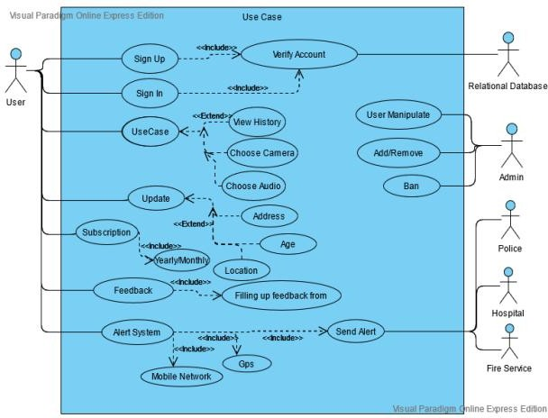

Figure 1: Use-case diagram of the software system.

* Class diagram:

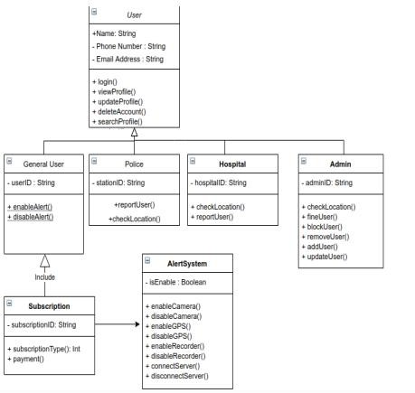

Figure 2: Class diagram of the software system.

* Activity diagram:

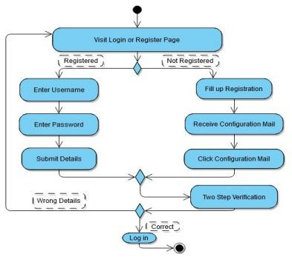

Figure 3: Activity diagram of the software system.

## UI/UX Design Specification

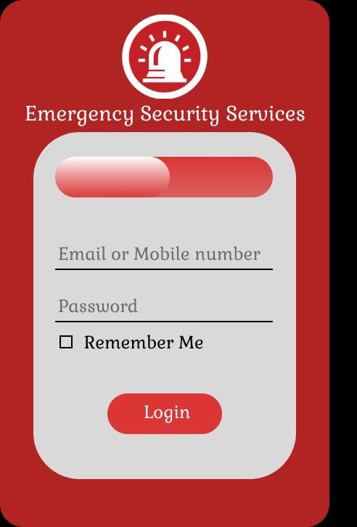

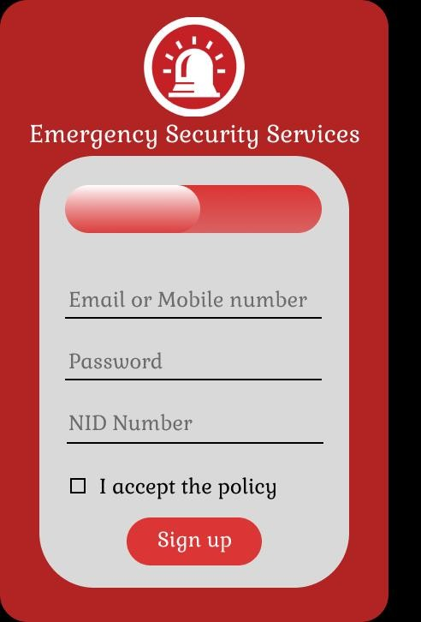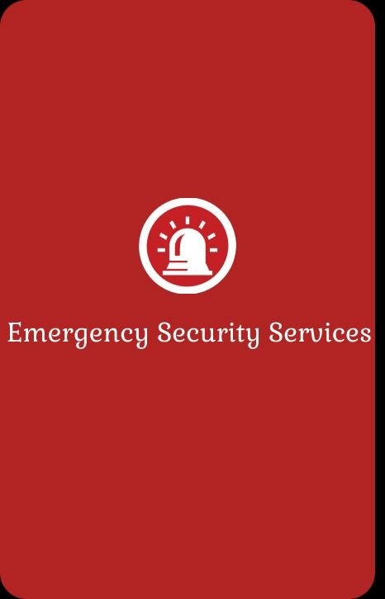

Figure 4: Login

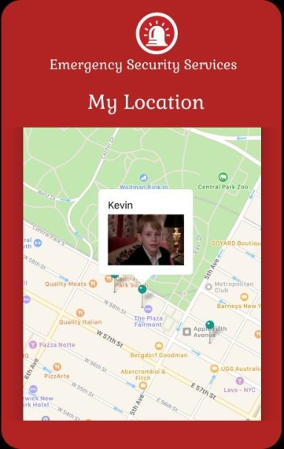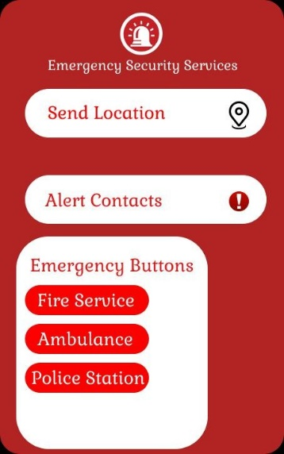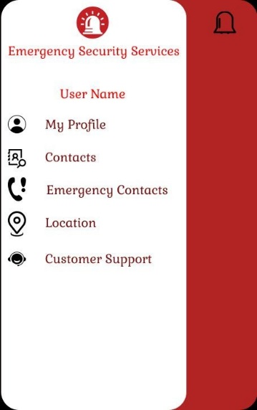

Figure 5: Sing Up & Send Location